 | PES University, Bengaluru  (Established under Karnataka Act No. 16 of 2013) | UE20CS904
Model 2025 : END SEMESTER ASSESSMENT (ESA)
M TECH DATA SCIENCE AND ARTIFICIAL INTELLIGENCE_ SEMESTER I
AMES model
Time: 3 Hrs | Answer All Questions | Max Marks: 100
Instructions
- Section A all answers should be handwritten in the answer script.
- Section B and Section C has to be answered in Jupyter notebook (python code)
Section A (20 marks)

1 | a) | Define descriptive vs. inferential statistics with one real-world example each. | 2
 | b) | Differentiate between scatter plot and correlation coefficient in terms of the insights they provide. | 2
 | c) | Explain conditional probability with a business-related example. | 2
 | d) | Define Type I and Type II error in hypothesis testing with illustrations. | 2
 | d) | What is image convolution ?  Compute the result of applying the following filter kernel on the center pixel of a 3×3 patch:  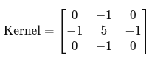  What visual effect does this filter have on the image? | 4
 | e) | What is the local and global minima in gradient descent algorithm ? | 4
 | f) | How can the second derivative test be used to identify maxima, minima, or points of inflection? Provide an example function and show the steps. | 4

Section B (40 marks)
2 | a) | The dataset contains the variable age of billionaires. A researcher claims that the average age of billionaires is 60 years.  (i) Perform a one-sample t-test at the 0.05 significance level to determine if the mean age differs from 60. (5 marks)  (ii) Construct a 95% confidence interval for the mean age. (3 marks) | 8
 | b) | Using the dataset, billionaires are classified into Self-made and Inherited based on their source. A study compares the average net worth between these two groups.  (i) Perform an independent two-sample t-test at the 0.01 significance level to check if there is a significant difference in mean net worth. (5 marks)  (ii) Construct a 99% confidence interval for the difference in means. (3 marks) | 8
 | c) | The dataset provides gdp_country values for billionaire countries. An analyst claims that the average GDP of countries in the dataset is 1 trillion USD (1_000_000_000_000).  (i) Perform a one-sample t-test at the 0.05 significance level to test this claim. (5 marks)  (ii) Construct a 95% confidence interval for the mean GDP. (3 marks) | 8
 | d) | The dataset provides the age and net worth (finalWorth) of billionaires.  (i) Perform a simple linear regression to model net worth based on age. (4 marks)  (ii) Predict the net worth of a billionaire aged 55 years. (2 marks)  (iii) Evaluate the statistical significance of the model using the p-value and R². (2 marks) | 8
 | e) | Using the dataset, billionaires are grouped by Region (derived from country) and Source of wealth (source).  (i) Perform a Chi-square test of independence to assess whether the source of wealth is independent of region. (5 marks)  (ii) Interpret the result using a 0.05 significance level. (3 marks) | 8

 | SECTION C (Matheatics part) – (40 MARKS)
a) | Consider the following matrix and answer the below 2 questions  A=[1,5,-1] , B=[3,2,4 ], C=[2, m, 1] , where ( m ) is an unknown scalar.  (i) Form a matrix ( M ) with these vectors as columns. For what value of ( m ), if any, do the vectors become linearly dependent? Also, find the rank of the matrix for this value of ( m ). (3 marks)  (ii) Check if the matrix ( M ) is an orthogonal matrix when ( m = 1 ). (3 marks) | 6
b) | Find the critical points of the function f(x)=$x^{4}$+ 4$x^{3}−{3x}^{2}+2$ | 6
c) | 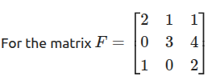  (i) Compute the Eigenvalues of ( F ). (4 marks)  (ii) Using eigenvalue properties, find the determinant of ) without direct computation. (4 marks) | 8
d) | Apply PCA step by step on the wine dataset and find out the principal components that capture 95% variances. (follow the steps given in the notebook.) | 10
e) | 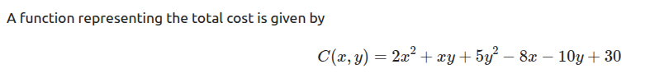  (i) Find the stationary points using partial derivatives. (4 marks)  (ii) Verify that the stationary point is indeed an extremum by checking the sign of partial derivatives around the point. (4 marks)  (iii) Calculate the minimum cost value at the stationary point. (2 marks) | 10

